Slot 1

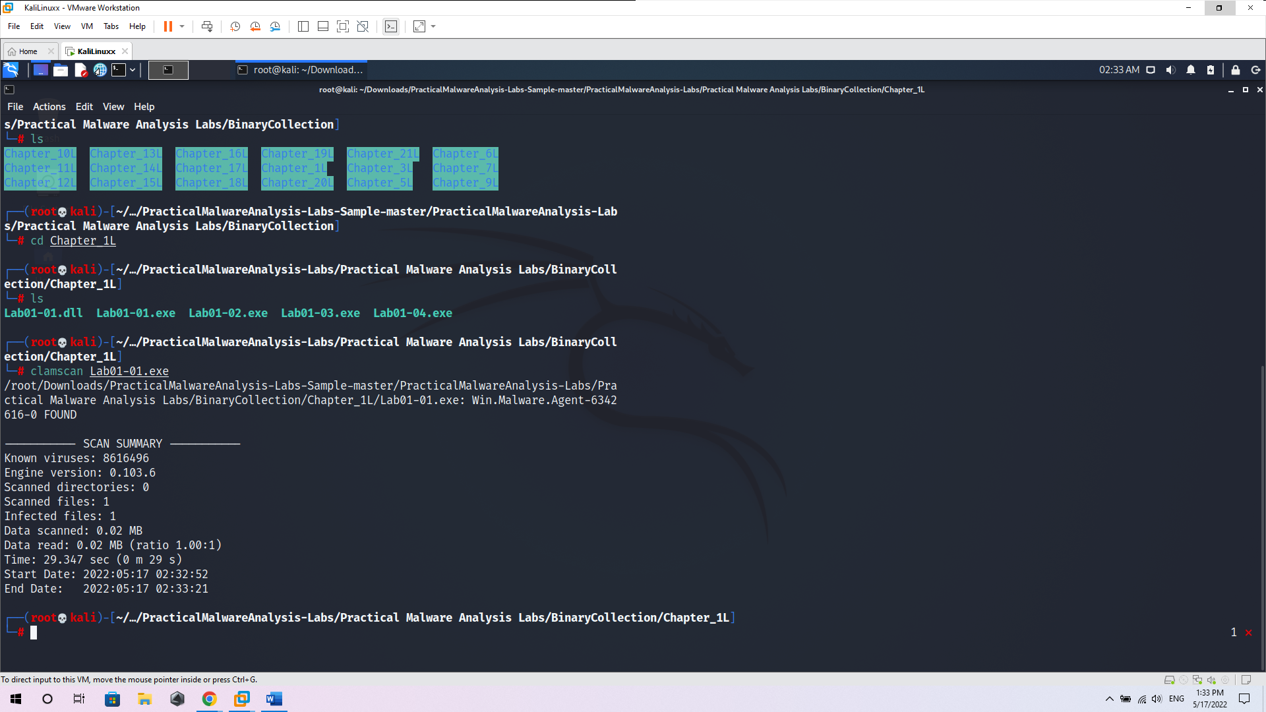

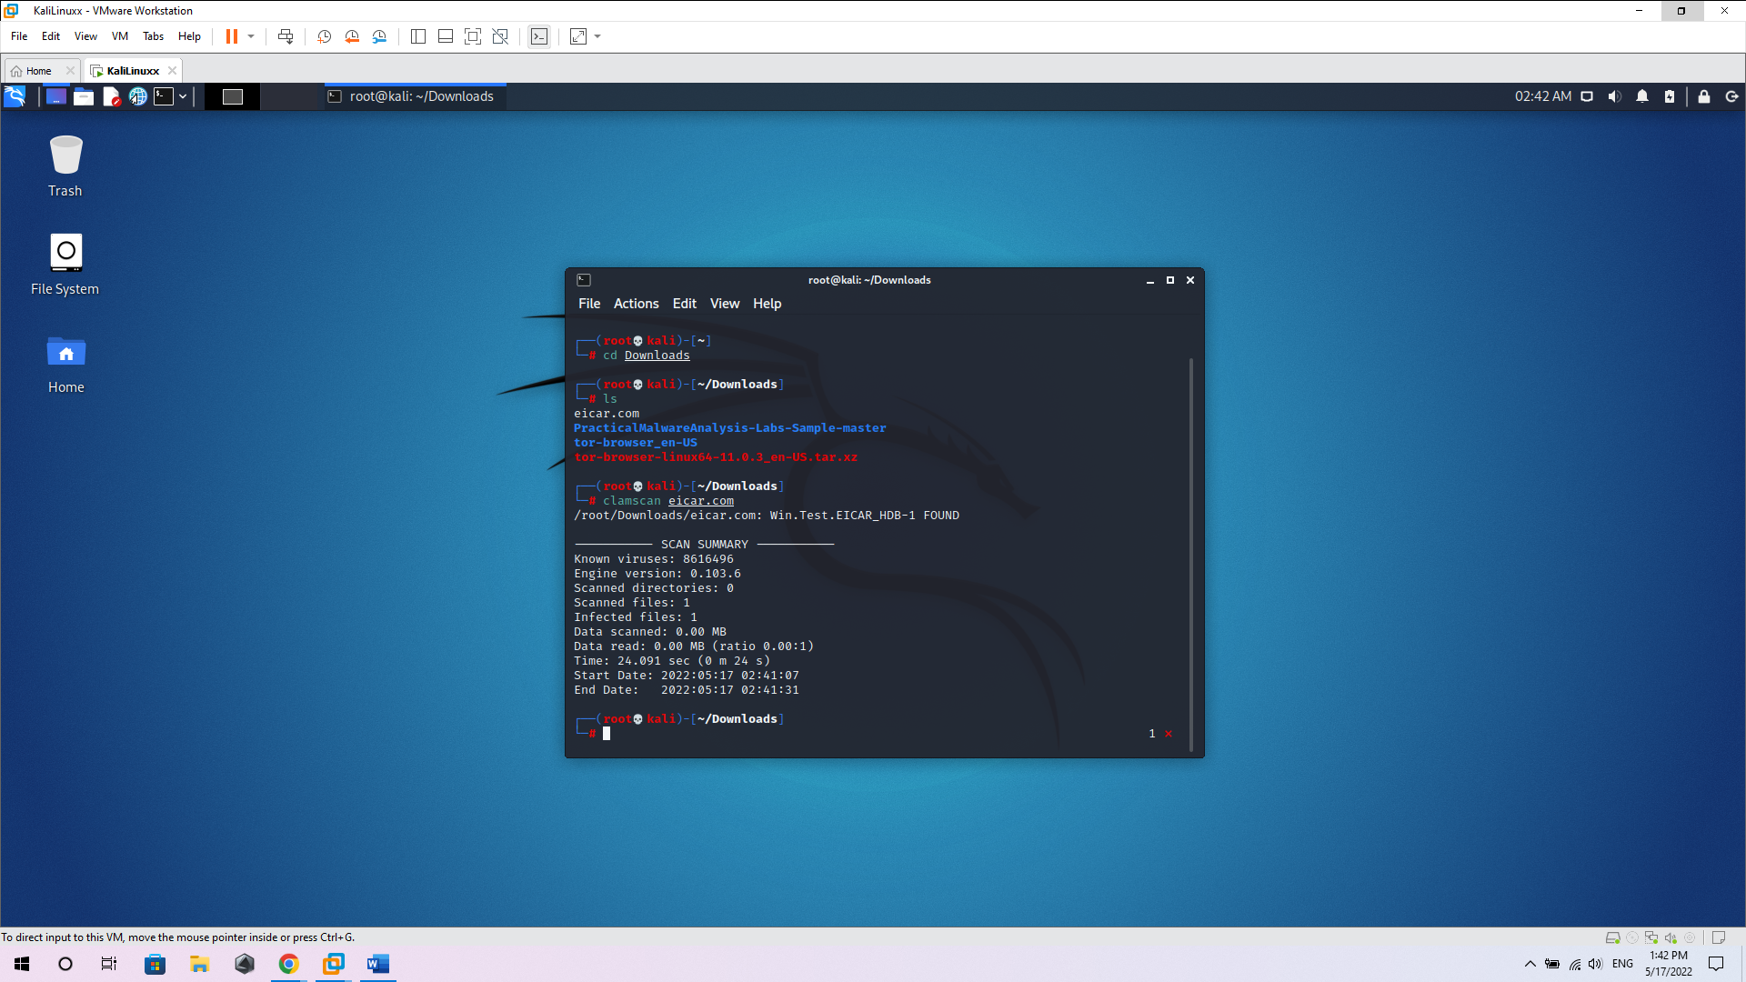

Slot 2

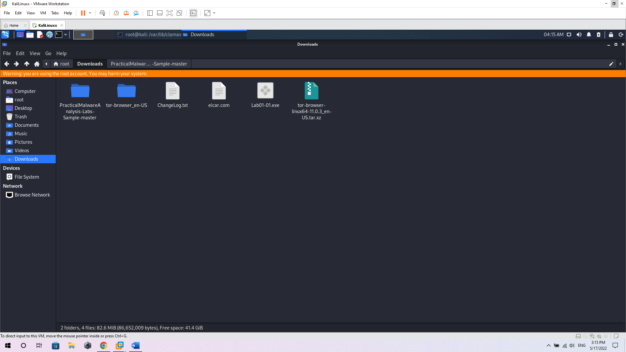

I have 3 files at the Download path including Changelog.txt, eicar.com, Lab01-01.exe

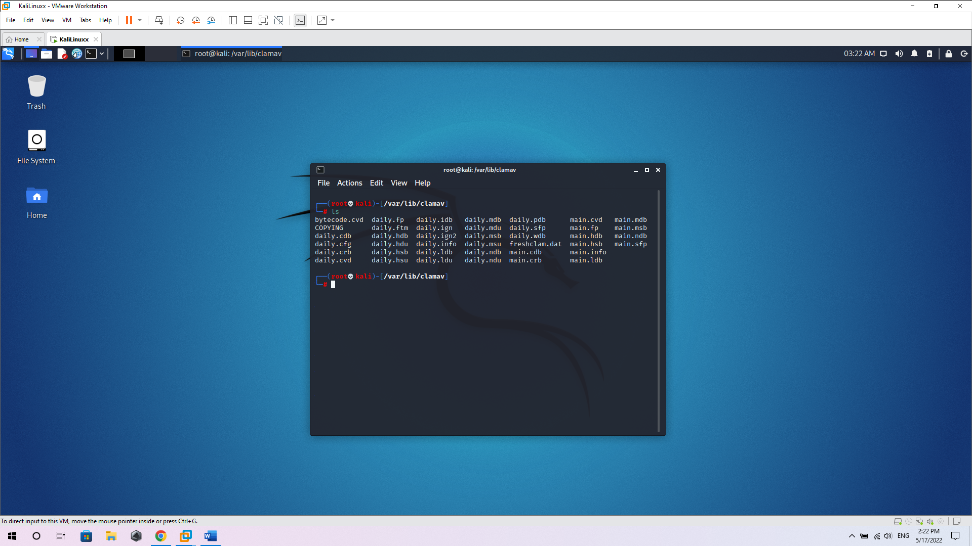

cd /var/lib/clamav

sigtool -u daily.cvd

sigtool -u main.cvd

ls

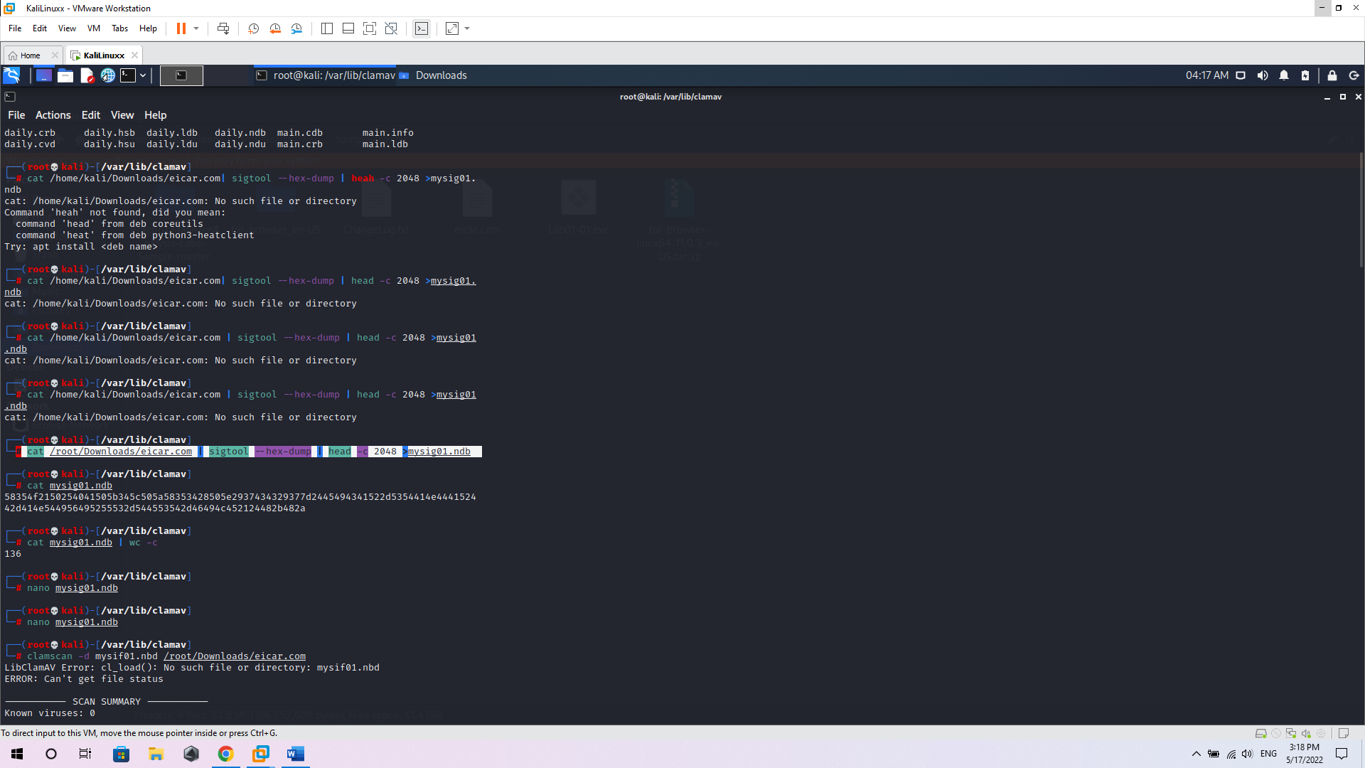

Use: cat /root/Downloads/eicar.com | sigtool --hex-dump | head -c 2048 >mysig01.ndb to create a signature for the file

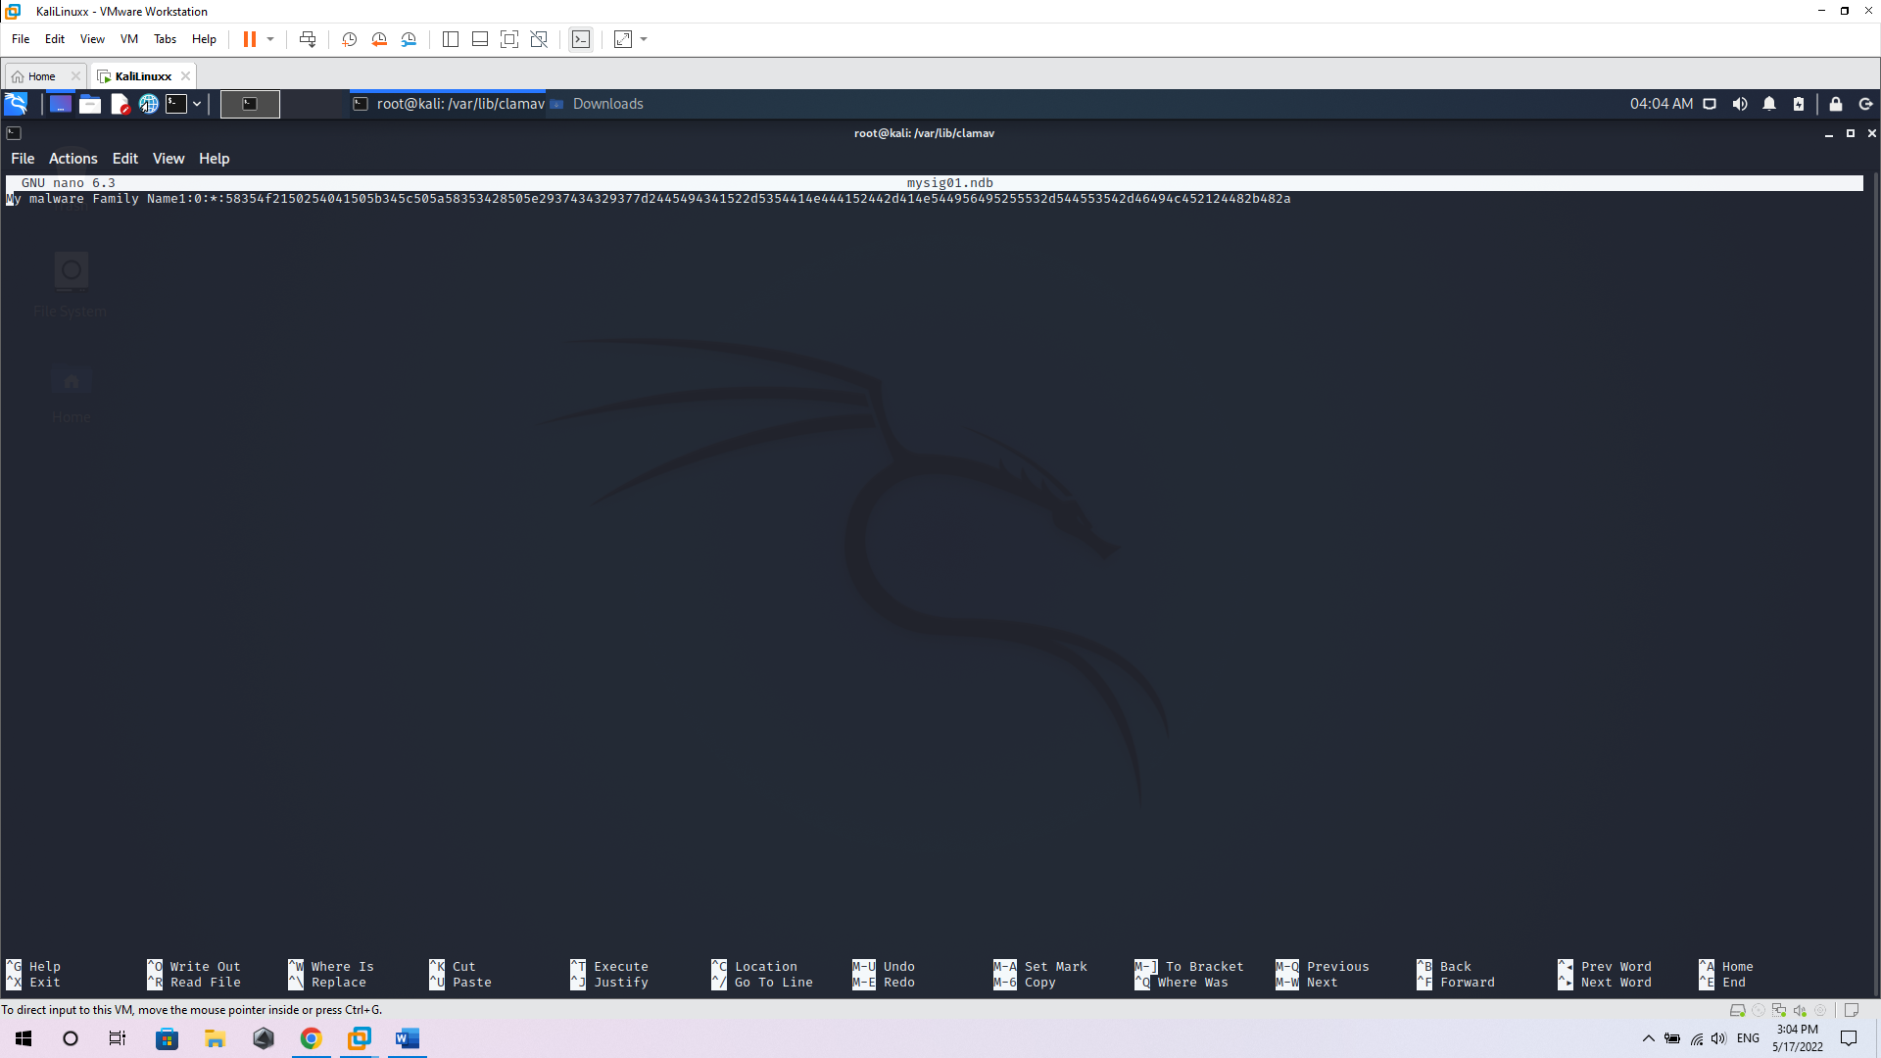

Nano file to to add an identifier for the virus to help search the virus database later

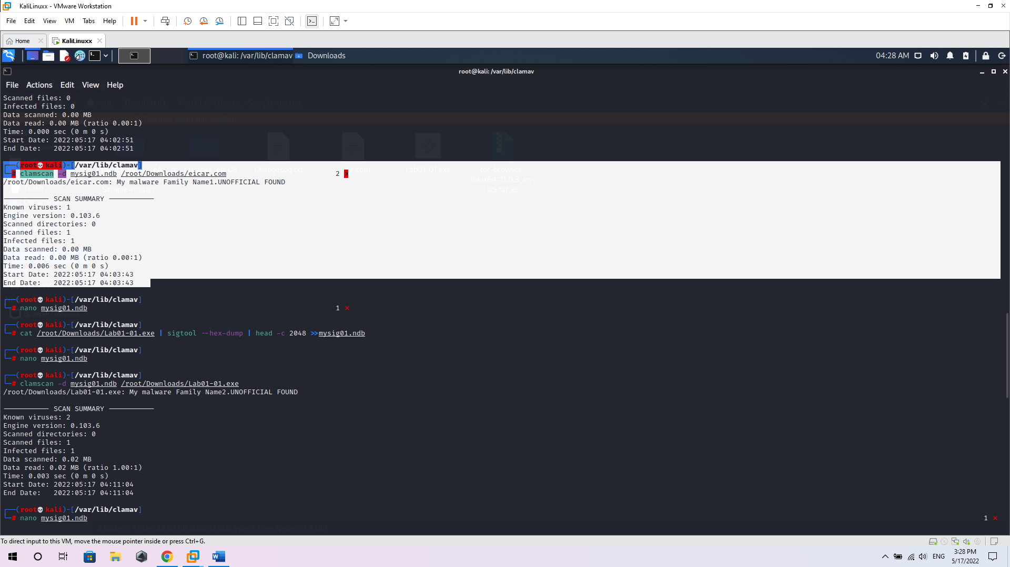

lamscan to test the virus identification file I made

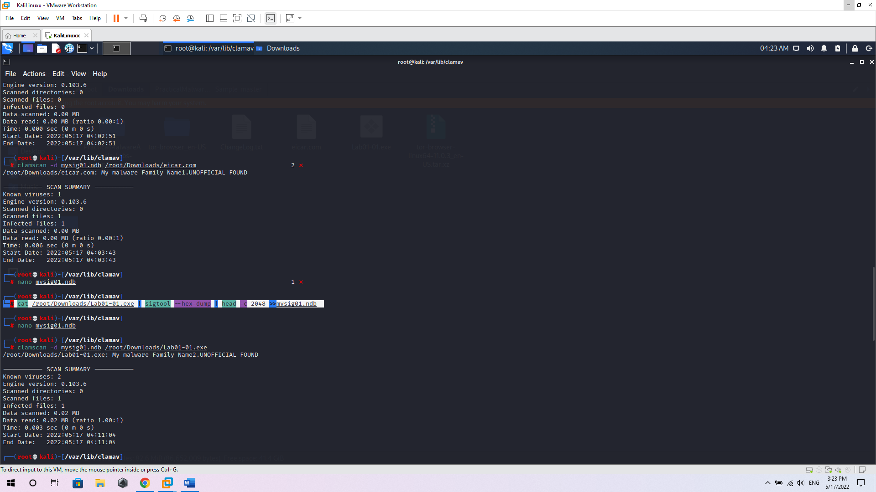

Test again with more 2 file

Use cat /root/Downloads/Lab01-01.exe | sigtool --hex-dump | head -c 2048 >>mysig01.ndb to create a signature for the file

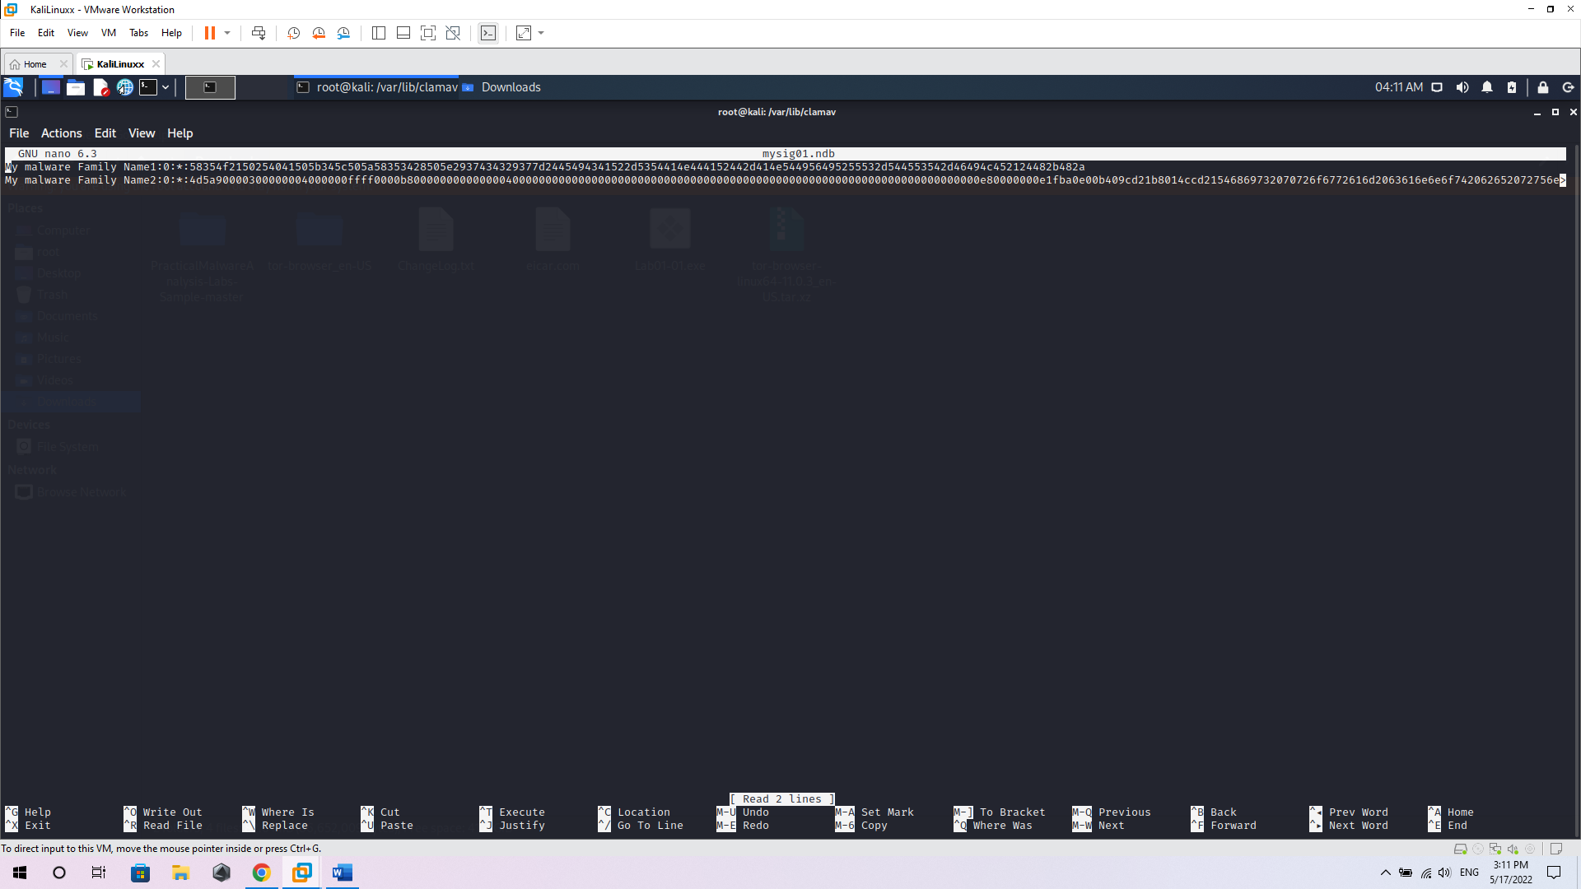

Nano file to to add an identifier for the virus to help search the virus database later

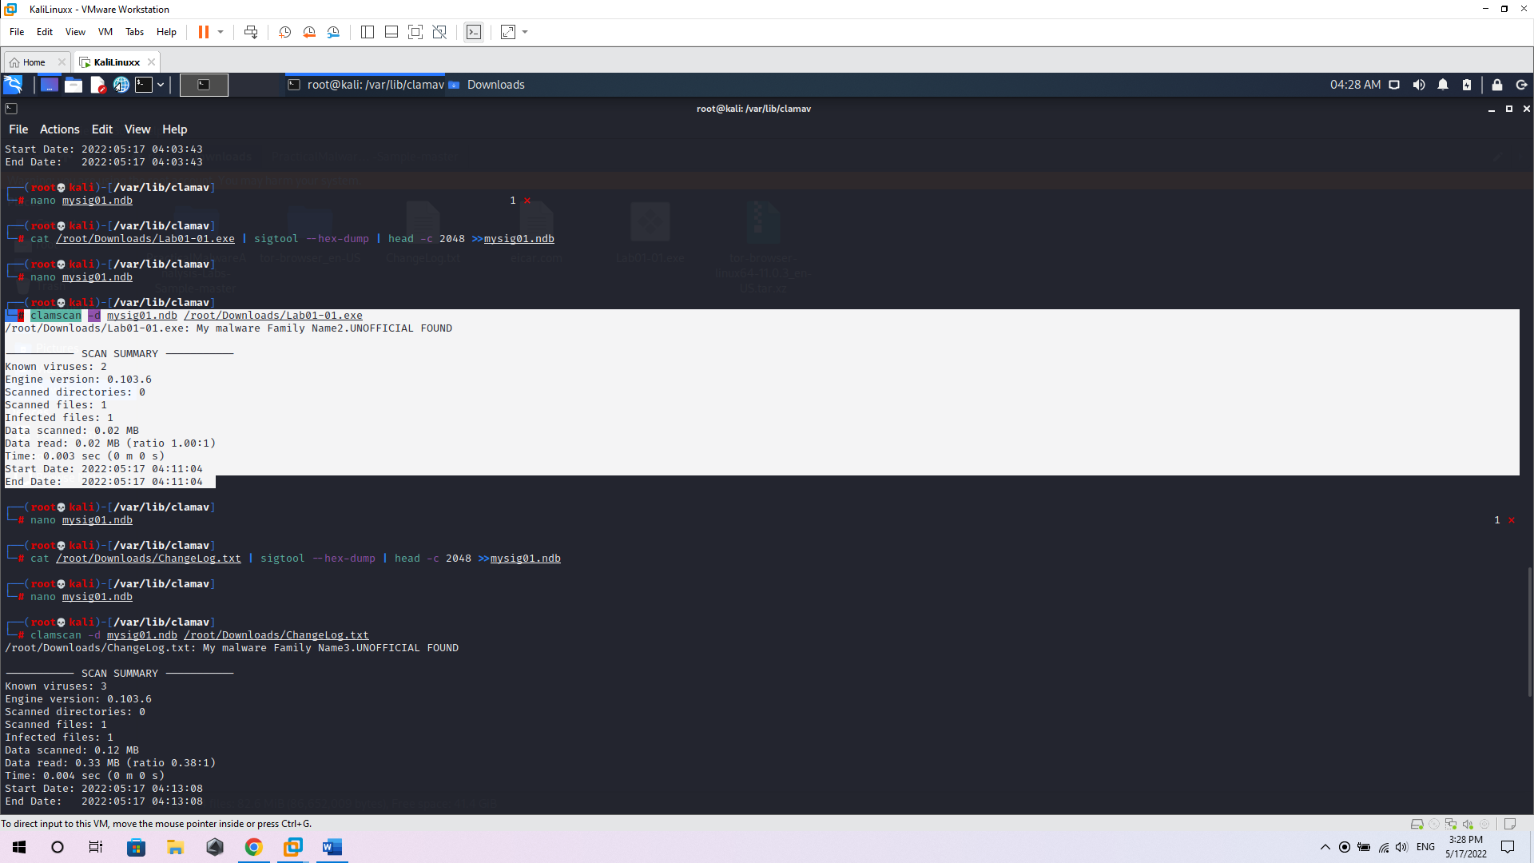

lamscan to test the virus identification file I made

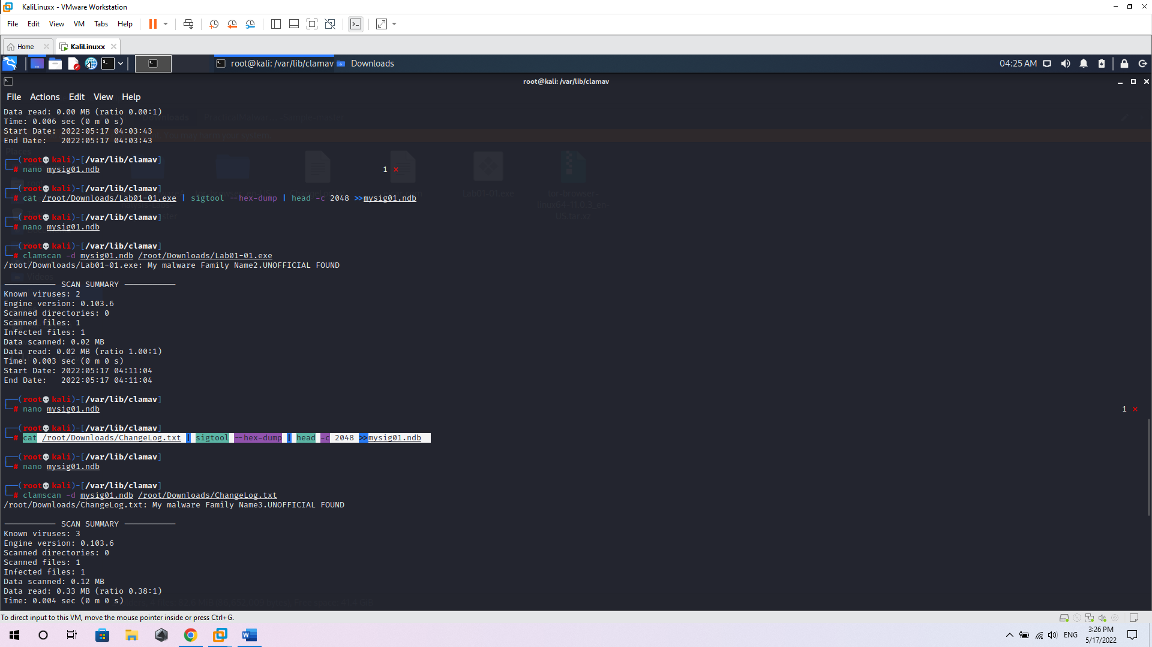

Use cat /root/Downloads/ChangeLog.txt | sigtool --hex-dump | head -c 2048 >>mysig01.ndb to create a signature for the file

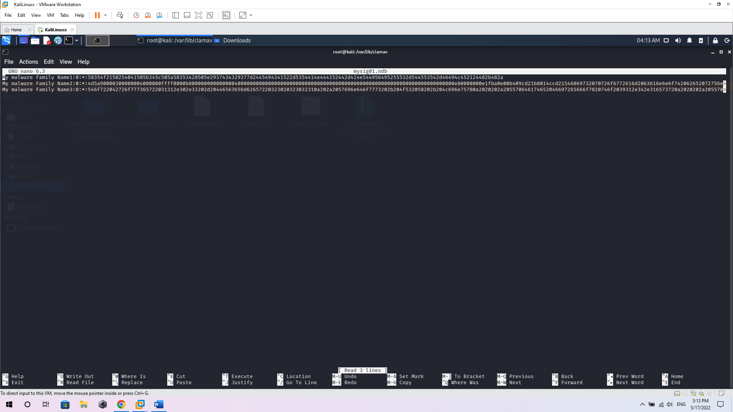

Nano file to to add an identifier for the virus to help search the virus database later

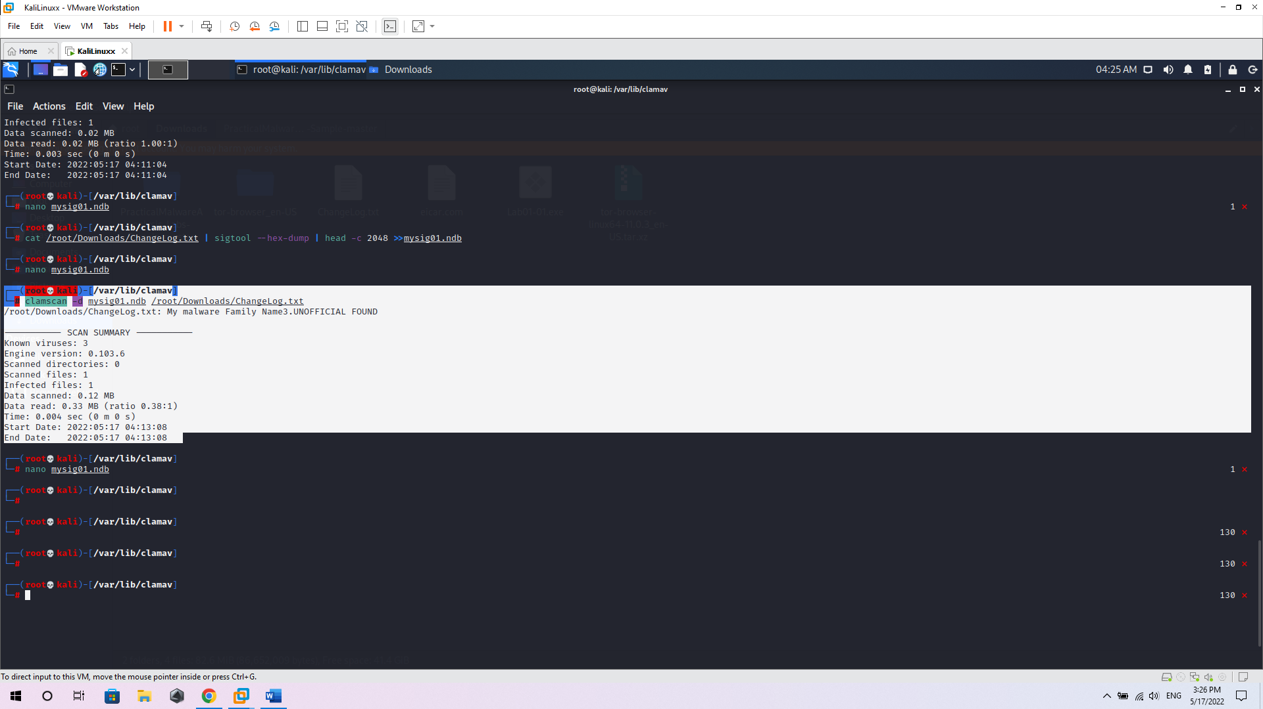

lamscan to test the virus identification file I made